## 2.3.5 Hamburger Overlay

### 2.3.5.1 Purpose

* This view is an overlay to a side menu that is hidden in plain view until the Hamburger button has been clicked.
* After revealing the menu, the user can navigate to several different pages/functions:
  + Home page
  + Search bar
  + Favorites page
  + Settings
  + Tutorial feature
  + About page
* This overlay is more for navigation convenience for the user.
* The user can gain access to this page by clicking the Hamburger button that is always on the right hand corner of the header of a page.
* The user can go to the pages or access a function that was listed above.

### 2.3.5.2 Wireframe Screenshot

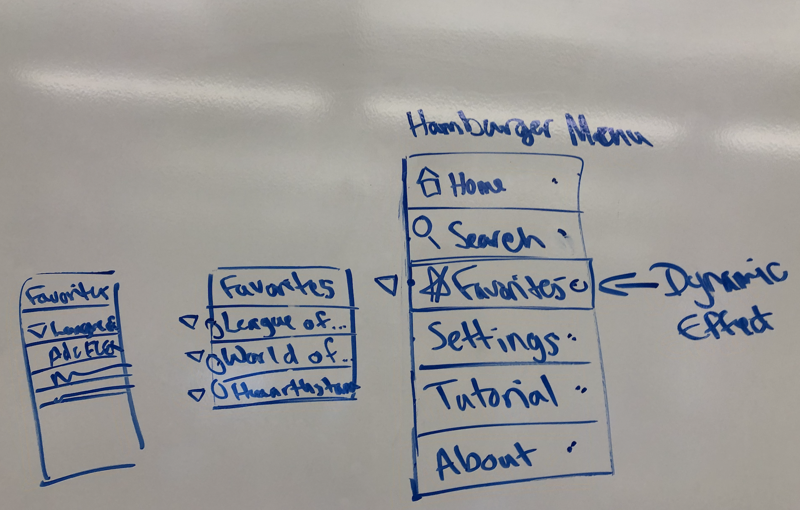

### 2.3.5.3 Mockup Screenshot Created the overlay, going to implement it fully in the Prototyped version:

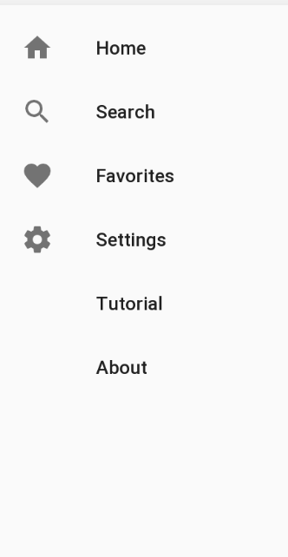

### 2.3.5.4 Prototype Screenshot Screenshot of prototype for this interface goes here.

### 2.3.5.5 Design Commentary

Talk about how your UI changed as it went through the steps of Wireframe -> Mockup -> Prototype. What did you like / dislike at each stage that influenced the next round of UI development?